A: Photosynthetic reaction, rate of photosynthesis and use of glucose from photosynthesis.
- Phytoplankton are microscopic aquatic plants. They utilise the energy transferred from the sun for photosynthesis.

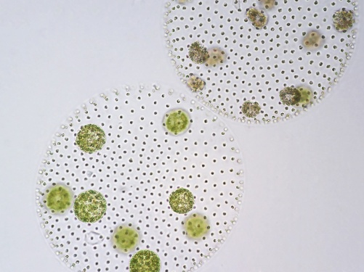
Scientists working in the North Sea collected 500 samples of sea water at the same depth and location every month for a whole year. They measured the number of phytoplankton and water temperature for each sample and calculated the mean. The graph shows the mean number of phytoplankton and water temperature each month.
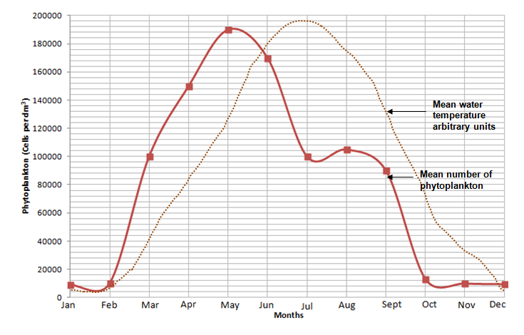
100 000
190 000
- Explain why the numbers of phytoplankton are lower in winter months. (2)
- Calculate the percentage decrease in numbers of phytoplankton between May and July. Write your answer to 3 significant figures. (3)
- Suggest the cause and reason why the numbers of phytoplankton fall at the start of summer. (2)

- Van Helmont was a scientist born in the Netherlands in 1580. It was generally believed at that time that plants gained mass by eating soil.
Van Helmont designed an experiment to test this idea. The results of his experiment are seen below.
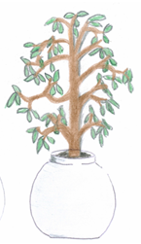
Only water was added for five years.
Willow plant in same iron pot.
Willow plant has a mass of 77.3kg
Mass of dry soil is 90.043kg
Willow plant in an iron pot.
Willow plant has a mass of 2.5kg
Mass of dry soil is 91kg

- Write a conclusion for this experiment using only the information provided. Explain your reasoning. (4)

- List two extra investigations that would be needed to prove that the plant gained mass due to photosynthesis occurring? (2)
- There is a total of 7000 x 10⁹ tonnes of carbon dioxide in the atmosphere. Photosynthesis converts 100 x 10⁹ tonnes per year into carbon compounds such as carbohydrates, protein or lipids. We call this carbon fixing.
- Calculate as a percentage, how much carbon is fixed per year from the atmosphere. Express your answer to 2 significant figures. (2)
- Suggest two reasons why the amount of carbon dioxide in the atmosphere stays relatively constant. (2)

- A student carried out the practical which involved testing the effect of light intensity on the rate of photosynthesis. The pondweed was left to settle for 15 minutes in between each set of results being collected. The equipment was set up as shown below:
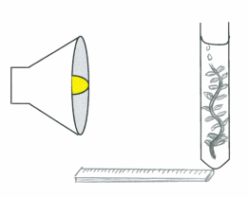
pondweed
0.2% sodium hydrogen
carbonate solution

bubbles of gas
bench Lamp
metre ruler
The student recorded the results in the table below:
Distance of lamp from boiling tube (cm) | Number of bubbles counted in 1 minute
 | Trial 1 | Trial 2 | Trial 3 | Mean number of whole bubbles | Light intensity ( in standard form)  1/d²
20 | 10 | 15 | 18
40 | 10 | 12 | 16
60 | 9 | 10 | 14
80 | 6 | 7 | 10
100 | 3 | 4 | 6

- Determine the mean number of bubbles of gas collected for each distance and record in the table. (2)

- (Higher Tier) Calculate the light intensity for each experiment and record in the table. (5)

- Plot a graph to show the effect of light intensity on the rate of photosynthesis. (4)

- Use your graph to estimate the number of whole bubbles which would be released from the pondweed when the lamp was at a distance of 30cm. (3)

- All the data shows an increase in number of bubbles collected during trial 3. Suggest two reasons why this may have occurred. Explain how this could be verified and how would you improve the method for the future. (6)

- Photosynthesis is an endothermic reaction. Explain what this statement means. (2)

Extended response question
- A farmer in the UK decided to grow lemon trees in two greenhouses in order to sell the fruit locally.
He had grown some lemon trees outside but these had not produced sufficient lemons to make it worthwhile. He decided to heat one of the greenhouses to 35°C and the other to 45°C.
There were the same numbers of lemon trees in each greenhouse and all other factors were kept constant. Both greenhouses contained healthy plants.
The lemons were all sold at 55p each.

 | Greenhouse A (35°C) | Greenhouse B (45°C)
Number of lemons produced in one year | 1050 | 879
Cost to heat the greenhouse per year | £438.00 | £492.80
Profit made

- Using the data given calculate the profit that the farmer made from each greenhouse and complete the table. (4)

- The farmer was surprised by the results.

Use your knowledge of limiting factors to explain the results and suggest three changes the farmer should make to increase productivity and profit for the following year in Greenhouse A. (6)

- The following graph shows the effect of light intensity on the rate of photosynthesis for two plant species.

- Explain which plant is most likely to thrive in sunny positions in a garden. (3)

- Explain why species A might be unable to further increase the rate of photosynthesis even though it is in the same environmental conditions as species B and both receive the same amount of water. (2)

- (Higher tier) The graph shows the effect of temperature and carbon dioxide concentration on the rate of photosynthesis.

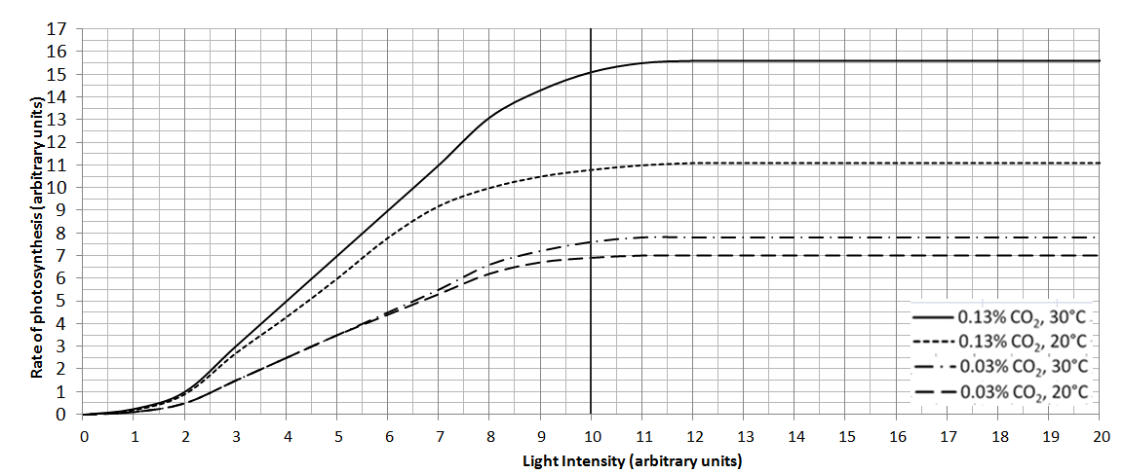

If light intensity is kept constant at 10 units, calculate the percentage increase in photosynthetic rate when:

- temperature is increased from 20°C to 30°C and carbon dioxide is kept constant at 0.03%. (2)

- carbon dioxide is increased from 0.03% to 0.13% and temperature is kept constant at 20°C. (2)

B. Transport in plants and structure of the leaf
1. Diffusion and active transport are vital processes in providing a plant with all the substances it needs to grow. Explain how these two processes deliver the named substances and describe where this occurs. (6)

2. Explain how the structure of a leaf is adapted for photosynthesis (4)

2. Extended response question:
Compare the processes of transpiration and translocation in a plant and explain the conditions that would bring about maximum transpiration. (6)

C. Plant hormones (Biology)
1. Extended response question:
Auxin is a plant hormone that controls growth.

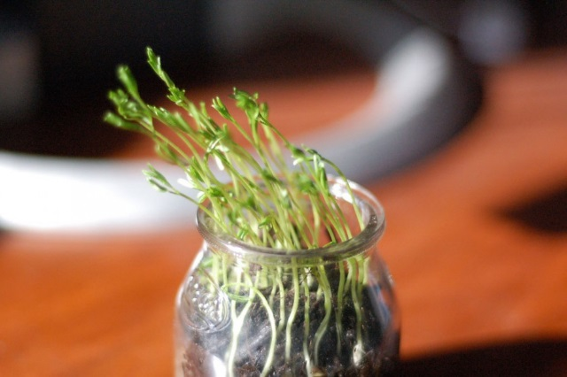

Describe and explain how auxin has made the plant grow towards the light. (6)

2. A team of scientists studied the effect of two weedkillers. Weedgone contained a plant growth hormone, Weedaway did not.
They tested the two weedkillers on potato crops and measured how many kilograms of potatoes were produced.
- Name one control variable and describe how they should keep it constant (2)

b. Here are the results of their investigation:
Year | 2008 | 2009 | 2010 | 2011 | 2012
Kg of potatoes from field treated with Weedgone (plant hormone) | 51 | 42 | 50 | 52 | 51
Kg of potatoes from field treated with Weedaway | 38 | 37 | 36 | 38 | 37

i. Calculate the mean for Weedgone. (2)

ii. Use the data to describe the effect of the plant hormone on the mass of potatoes produced. (2)

